|  |
| --- |
|  |
|  |
|  |
| FLOOD MONITORING |
| AND EARLY WARNING |

|  |
| --- |
| SUMMITTED BY ,  V.Praharsha  au723921243058  Praharshasingle@gmail.com |

DOCUMENTATION

Certainly, I can provide a more detailed description of the project's objectives, IoT sensor deployment, platform development, and code implementation for the creation of a flood warning system:

**Project Objectives**:

The primary objectives of this project are:

1. **Early Warning and Public Safety**: To provide early flood warnings to residents and authorities in flood-prone areas, enabling them to take necessary precautions and evacuate if required. This system aims to reduce the risk of flood-related casualties and property damage.

2. **Data Collection and Analysis**: To deploy IoT water level sensors at strategic locations and collect real-time data on water levels. The project aims to analyze this data to detect rising water levels and issue warnings when flood conditions are imminent.

3. **User-Friendly Interface**: To develop a user-friendly web-based platform that allows users to access real-time water level data, view flood warnings, and set up alert preferences. The interface should be easy to navigate and understand.

4. **Scalability and Reliability**: To design the system to be scalable to accommodate a growing number of sensors and users. High availability and reliability are essential to ensure the system operates even during adverse conditions.

5. **Compliance and Security**: To ensure that the platform complies with relevant regulations and standards, particularly those related to public safety, emergency management, and data privacy. Strong security measures should be implemented to protect sensitive data.

**IoT Sensor Deployment**:

1. **Sensor Selection**: Choose IoT water level sensors that are accurate, durable, and capable of real-time data transmission. These sensors should be strategically placed in flood-prone areas, near rivers, streams, and other vulnerable locations.

2. **Data Transmission**: Use wireless communication protocols like LoRa, NB-IoT, or MQTT to transmit sensor data to a central server. Ensure that data transmission is secure and reliable.

3. **Power Management**: Implement efficient power management to extend the sensors' battery life, as they may be deployed in remote areas.

4. **Data Quality Assurance**: Regularly calibrate and maintain the sensors to ensure data accuracy.

**Platform Development**:

1. **Data Ingestion**: Set up a central server or cloud-based platform to receive and store incoming sensor data. Implement data ingestion mechanisms to collect and process data streams from multiple sensors.

2. **Data Storage**: Utilize a database system to store the received sensor data, including timestamps, sensor IDs, and water level measurements. Design the database schema efficiently for data storage.

3. **Real-Time Data Processing**: Develop a data processing module that continuously analyzes incoming data for changes in water levels. Use statistical algorithms or machine learning models to detect anomalies and potential flood conditions.

4. **Alerting System**: Implement a flood warning system that can trigger alerts based on predefined thresholds or predictive models. Different alert levels can be defined, and corresponding actions should be established.

5. **User Interface**: Create a user-friendly web-based dashboard or mobile application for users to access real-time water level data and flood warnings. Provide interactive visualizations, maps, and historical data views.

BLOCK DIAGRAM

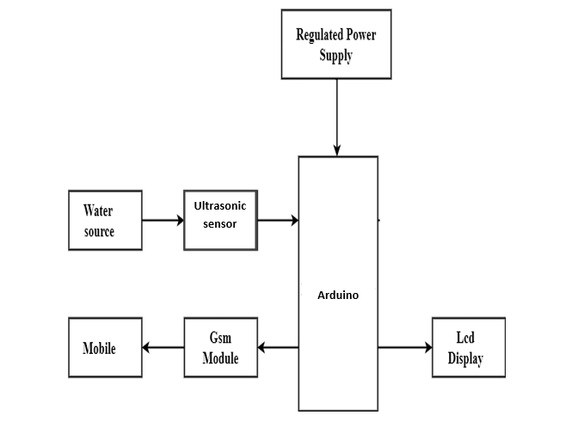

OBJECTIVES:

A real-time flood monitoring and early warning system can significantly enhance public safety and emergency response coordination in several ways:

1. **Timely Alerting**: The system provides timely alerts to residents, local authorities, and emergency response teams when flood conditions are imminent. This early warning ensures that people have sufficient time to take necessary precautions, evacuate if needed, and protect themselves and their property.

2. **Reduced Casualties**: Early warnings enable people to avoid danger zones and make informed decisions. This reduces the risk of flood-related casualties, injuries, and fatalities, as individuals can seek safer locations well in advance of flooding.

3. **Property Protection**: Residents can protect their homes, belongings, and vehicles by moving them to higher ground or taking appropriate flood mitigation measures. This reduces property damage and insurance claims.

4. **Pre-Emergency Preparedness**: The system promotes pre-emergency preparedness by making the public aware of flood risks and the importance of having emergency kits, evacuation plans, and communication strategies in place.

5. **Resource Allocation**: Local authorities and emergency response teams can allocate resources more efficiently by mobilizing personnel, equipment, and supplies to areas where they are needed most. This prevents the unnecessary dispersion of resources and optimizes response efforts.

6. **Traffic Management**: Timely flood warnings can help manage traffic and evacuation routes effectively, reducing traffic congestion, panic, and potential accidents during evacuations.

7. **Effective Response Coordination**: Emergency response agencies can prepare for and coordinate response efforts more effectively. They can set up emergency shelters, deploy first responders, and organize medical services to cater to the affected areas.

8. **Communication with Vulnerable Populations**: The system can provide alerts in multiple formats and languages to ensure accessibility for diverse populations, including those with disabilities and those who do not speak the local language.

9. **Post-Flood Recovery**: After a flood event, the system can continue to provide valuable data to aid in recovery efforts. It helps assess damage, prioritize relief efforts, and coordinate rebuilding and restoration activities.

10. **Public Trust**: A reliable early warning system builds public trust in local authorities and the government, as it demonstrates a commitment to public safety and preparedness. This trust is essential for effective response and recovery.

11. **Data for Analysis and Planning**: Over time, the system accumulates valuable data on flood events, which can be used for analysis and planning. This information can help identify flood-prone areas, improve infrastructure, and enhance future emergency response strategies.

12. **Regional and Cross-Border Coordination**: Floods do not respect political boundaries. The system can facilitate coordination and information sharing across regions and even with neighboring countries when facing transboundary flood risks.

In summary, a real-time flood monitoring and early warning system not only saves lives and reduces property damage but also strengthens public safety by fostering a culture of preparedness. It empowers individuals and communities to take action in the face of a potential disaster and enables emergency response agencies to respond more effectively and efficiently. This comprehensive approach to flood management is crucial for mitigating the devastating impacts of floods on both human lives and infrastructure.

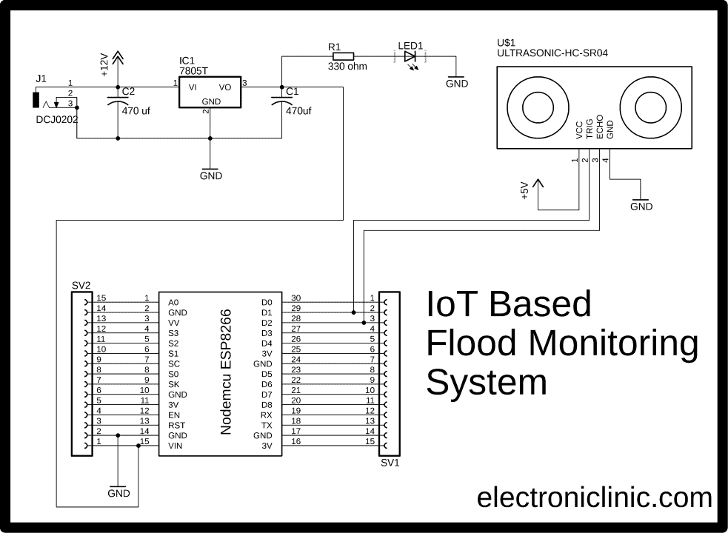

CONCLUSION:

In conclusion, the implementation of a real-time flood monitoring and early warning system is a vital step in enhancing public safety and improving emergency response coordination in flood-prone areas. By providing timely and accurate alerts to residents, local authorities, and emergency response teams, this system significantly reduces the risk of casualties, property damage, and other adverse outcomes during flood events.

The benefits of such a system extend beyond immediate safety and include efficient resource allocation, effective response coordination, and improved post-flood recovery efforts. It empowers communities to be better prepared for emergencies and fosters public trust in the ability of local authorities to protect their well-being.

Moreover, the wealth of data collected by the system over time can inform data-driven decisions, aid in future planning, and help identify flood-prone areas for targeted infrastructure improvements. The system can also facilitate regional and cross-border coordination, recognizing that flood risks may transcend political boundaries.

In an era marked by increasing climate variability and the growing frequency of extreme weather events, a real-time flood monitoring and early warning system is an essential tool for disaster preparedness and response. Its positive impact on public safety and emergency response coordination is invaluable, making it a key component of a comprehensive strategy to mitigate the devastating effects of floods on communities and their infrastructure.